**MP Practical- 3**

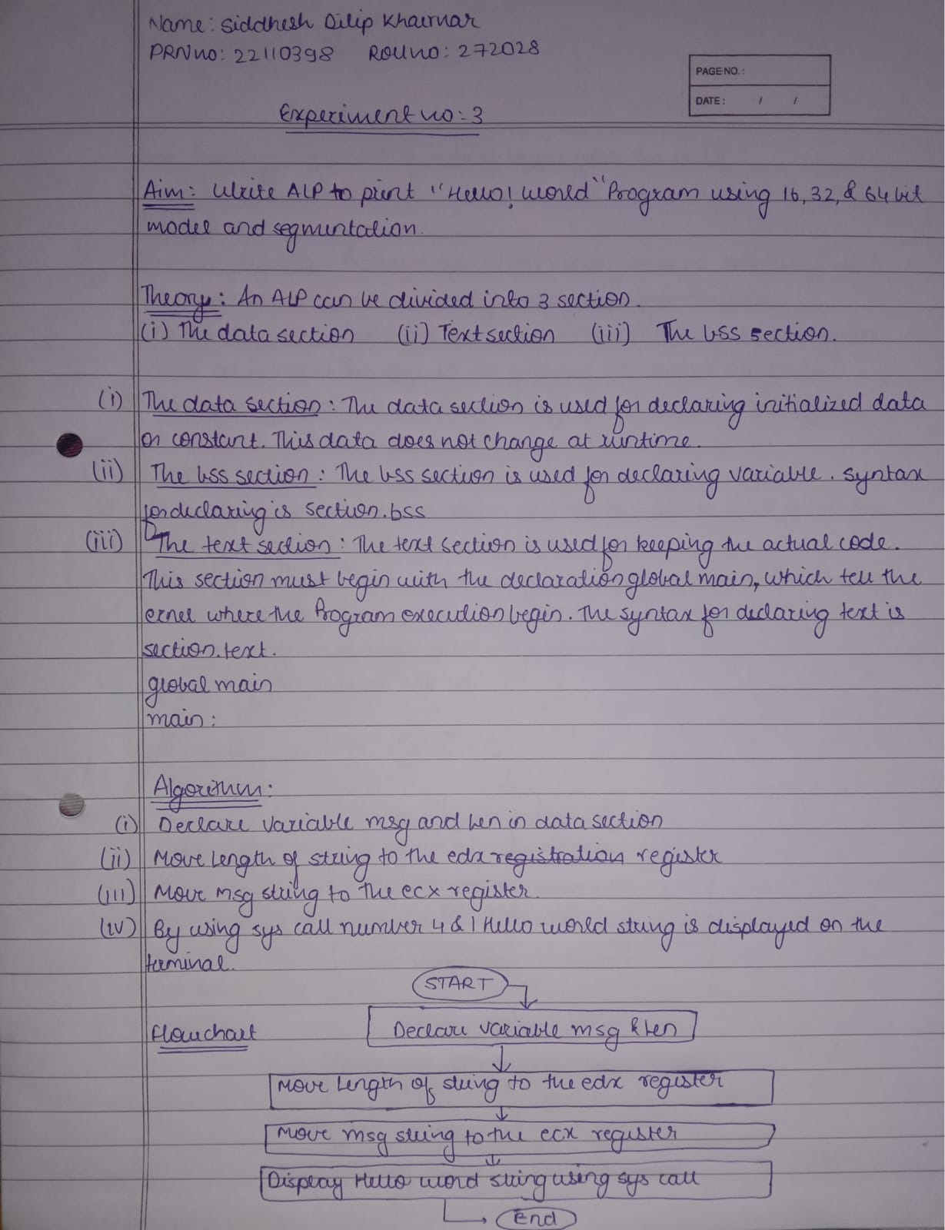

**Code:**

section .text

global _start ;must be declared for using gcc

_start: ;tell linker entry point

mov edx, len ;message length

mov ecx, msg ;message to write

mov ebx, 1 ;file descriptor (stdout)

mov eax, 4 ;system call number (sys_write)

int 0x80 ;call kernel

mov edx, len1 ;message length

mov ecx, msg1 ;message to write

mov ebx, 1 ;file descriptor (stdout)

mov eax, 4 ;system call number (sys_write)

int 0x80 ;call kernel

mov edx, len2 ;message length

mov ecx, msg2 ;message to write

mov ebx, 1 ;file descriptor (stdout)

mov eax, 4 ;system call number (sys_write)

int 0x80 ;call kernel

mov eax, 1 ;system call number (sys_exit)

int 0x80 ;call kernel

section .data

msg db 'Ritesh Jawale',0xa ;our dear string

len equ $ - msg ;length of our dear string

msg1 db 'AI&DS',0xa

len1 equ $ - msg1

msg2 db 'VIIT',0xa

len2 equ $ - msg2

**Output:**

